1. ORGAN OF SIGHT. STRUCTURE OF EYEBALL TUNICS. THE REFRACTORY MEDIA OF EYEBALL. CHAMBERS OF EYE

2. ACCOMODATIVE APPARATUS ON OF THE EYEBALL. VISUAL ANALYZER PATHWAY. ACCESSORY STRUCTURES OF THE EYE: ORBITAL FASCIA, EYEBROWS, EYELIDS, CONJUCTIVA. LACRIMAL APPARATUS.

3. ORGANS OF HEARING AND EQUILIBRIUM. STRUCTURE OF OUTER AND MIDDLE EAR. STRUCTURE OF INTERNAL EAR. HEARING ANALYZER PATHWAY. ORGANS OF SMELL AND TASTE, PATHWAYS. STRUCTURE OF SKIN

Lesson No 23
THEME 1. ORGAN OF SIGHT. STRUCTURE OF EYEBALL TUNICS. THE REFRACTORY MEDIA OF EYEBALL. CHAMBERS OF EYE

Eye consists of eyeball, auxiliary eye organs and the optic nerve. Eyeball has nucleus and wall. Auxiliary eye apparatus includes eyelids, muscles of eyeball, lacrimal apparatus, orbital fasciae, vessels and nerves.
Eyeball is serrounded by adiposal body of orbite, muscles of eyeball and orbital fascia. Bony orbit is covered by periorbita. It has an anterior pole, posterior pole, and axis. Axis courses between poles. Optic axis starts from anterior pole to central fossa of the retina. Line that is found transversal on surface of eyeball and is found in the middle to distance between poles is called equator, and line passing perpendicularly to equator is called meridian.
Eyeball wall consists of three coats: fibrous (external), vascular (middle) and internal (retina).
Fibrous coat of eyeball subdivides on transparent cornea (anteriorly) and sclera (the rast). Venous sinus of sclera (Schlemm`s canal) localised between cornea and sclera.

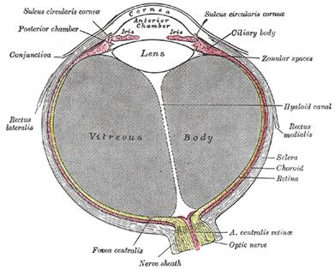
Vascular eye coat has: 1] proper vascular coat ‘choroidea’, which connects with sclera and delimited by perivascular space. 2] Ciliary body consists of ciliary corona and by 70 ciliary processes. There is ciliary muscle in ciliary body, its contraction provides eye accommodation. 3] Iris carries the round oriface in centre - pupilla. Smooth muscles, which form a pupil muscle-sphincter and pupil muscle-dilator are round the pupil.
VIDEO

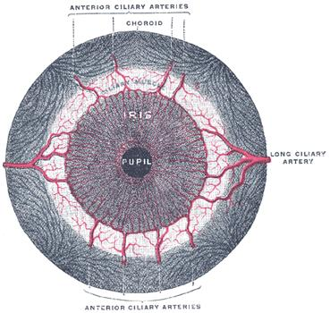

Internal coat of eyeball – ‘retina’. There are external pigmental layer and internal nervous layer in visual part of the retina. According to function they distinguish posterior larger visual part of retina, which contains rods and cones, and lesser blind part of retina. There are neither rods nor cones in blind part.

video

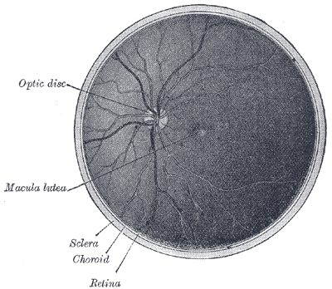

Ora serrata is the boundary between optic and blind parts, which accords with transition of choroid into ciliary body. In posterior part of retina is found a disc of the optic nerve that has a small concavity. Macula is located in the centre of retina. Central fossa is the place of best sight sharpness, where is observed most rods and cones.
Nucleus of eyeball consists of vitreous body, lens, and aqueous humor in anterior and posterior chambers.
Vitreous body represents by transparent mass without any vessels. It occupies largest portion of eyeball behind lens.
The transparent lens consists of tight layers of proteins. The thin, clear lens capsule encloses the lens and provides attachment for the suspensory ligament (zonular fibers).
Anterior chamber of eyeball placed between posterior surface of cornea surface and anterior surface of the iris. Posterior chamber is found between posterior surface by iris and anterior surface of lens. The anterior and posterior chambers are filled by aqueous humor, which produced by ciliary processes of ciliary body and unite each other by the medium of pupil. Between cornea and iris is found iridocorneal corner, which is filled by pectinate ligament with the Fontana`s spaces. Aqueous humor draines from anterior chamber through fountain spaces to the Schlemm`s canal (venous sinus of sclera).
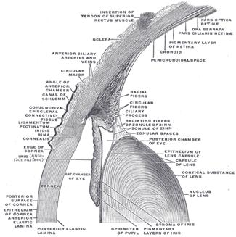

Organon Visus; The Eye
The bulb of the eye (bulbus oculi; eyeball), or organ of sight, is contained in the cavity of the orbit, where it is protected from injury and moved by the ocular muscles. Associated with it are certain accessory structures, viz., the muscles, fasciæ, eyebrows, eyelids, conjunctiva, and lacrimal apparatus.
The bulb of the eye is imbedded in the fat of the orbit, but is separated from it by a thin membranous sac, the fascia bulbi (page 1024). It is composed of segments of two spheres of different sizes. The anterior segment is one of a small sphere; it is transparent, and forms about one-sixth of the bulb. It is more prominent than the posterior segment, which is one of a larger sphere, and is opaque, and forms about five-sixths of the bulb. The term anterior pole is applied to the central point of the anterior curvature of the bulb, and that of posterior pole to the central point of its posterior curvature; a line joining the two poles forms the optic axis. The axes of the two bulbs are nearly parallel, and therefore do not correspond to the axes of the orbits, which are directed forward and lateralward. The optic nerves follow the direction of the axes of the orbits, and are therefore not parallel; each enters its eyeball 3 mm. to the nasal side and a little below the level of the posterior pole. The bulb measures rather more in its transverse and antero-posterior diameters than in its vertical diameter, the former amounting to about 24 mm., the latter to about 23.5 mm.; in the female all three diameters are rather less than in the male; its antero-posterior diameter at birth is about 17.5 mm., and at puberty from 20 to 21 mm.
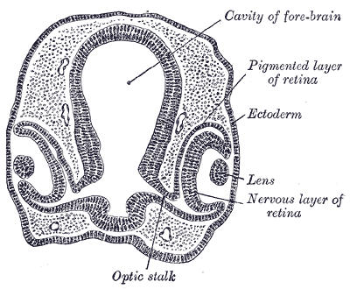
Transverse section of head of chick embryo of fifty-two hours’ incubation.
Development.—The eyes begin to develop as a pair of diverticula from the lateral aspects of the forebrain. These diverticula make their appearance before the closure of the anterior end of the neural tube; after the closure of the tube they are known as the optic vesicles. They project toward the sides of the head, and the peripheral part of each expands to form a hollow bulb, while the proximal part remains narrow and constitutes the optic stalk (863, 864). The ectoderm overlying the bulb becomes thickened, invaginated, and finally severed from the ectodermal covering of the head as a vesicle of cells, the lens vesicle, which constitutes the rudiment of the crystalline lens. The outer wall of the bulb becomes thickened and invaginated, and the bulb is thus converted into a cup, the optic cup, consisting of two strata of cells (864). These two strata are continuous with each other at the cup margin, which ultimately overlaps the front of the lens and reaches as far forward as the future aperture of the pupil. The invagination is not limited to the outer wall of the bulb, but involves also its postero-inferior surface and extends in the form of a groove for some distance along the optic stalk, so that, for a time, a gap or fissure, the choroidal fissure, exists in the lower part of the cup (865). Through the groove and fissure the mesoderm extends into the optic stalk and cup, and in this mesoderm a bloodvessel is developed; during the seventh week the groove and fissure are closed and the vessel forms the central artery of the retina. Sometimes the choroidal fissure persists, and when this occurs the choroid and iris in the region of the fissure remain undeveloped, giving rise to the condition known as coloboma of the choroid or iris.
The retina is developed from the optic cup. The outer stratum of the cup persists as a single layer of cells which assume a columnar shape, acquire pigment, and form the pigmented layer of the retina; the pigment first appears in the cells near the edge of the cup. The cells of the inner stratum proliferate and form a layer of considerable thickness from which the nervous elements and the sustentacular fibers of the retina, together with a portion of the vitreous body, are developed. In that portion of the cup which overlaps the lens the inner stratum is not differentiated into nervous elements, but forms a layer of columnar cells which is applied to the pigmented layer, and these two strata form the pars ciliaris and pars iridica retinæ.
The cells of the inner or retinal layer of the optic cup become differentiated into spongioblasts and germinal cells, and the latter by their subdivisions give rise to neuroblasts. From the spongioblasts the sustentacular fibers of Müller, the outer and inner limiting membranes, together with the groundwork of the molecular layers of the retina are formed. The neuroblasts become arranged to form the ganglionic and nuclear layers. The layer of rods and cones is first developed in the central part of the optic cup, and from there gradually extends toward the cup margin. All the layers of the retina are completed by the eighth month of fetal life.
The optic stalk is converted into the optic nerve by the obliteration of its cavity and the growth of nerve fibers into it. Most of these fibers are centripetal, and grow backward into the optic stalk from the nerve cells of the retina, but a few extend in the opposite direction and are derived from nerve cells in the brain. The fibers of the optic nerve receive their medullary sheaths about the tenth week after birth. The optic chiasma is formed by the meeting and partial decussation of the fibers of the two optic nerves. Behind the chiasma the fibers grow backward as the optic tracts to the thalami and mid-brain.

video

The crystalline lens is developed from the lens vesicle, which recedes within the margin of the cup, and becomes separated from the overlying ectoderm by mesoderm. The cells forming the posterior wall of the vesicle lengthen and are converted into the lens fibers, which grow forward and fill up the cavity of the vesicle (866). The cells forming the anterior wall retain their cellular character, and form the epithelium on the anterior surface of the adult lens. By the second month the lens is invested by a vascular mesodermal capsule, the capsula vasculosa lentis; the bloodvessels supplying the posterior part of this capsule are derived from the hyaloid artery; those for the anterior part from the anterior ciliary arteries; the portion of the capsule which covers the front of the lens is named the pupillary membrane. By the sixth month all the vessels of the capsule are atrophied except the hyaloid artery, which disappears during the ninth month; the position of this artery is indicated in the adult by the hyaloid canal, which reaches from the optic disk to the posterior surface of the lens. With the loss of its bloodvessels the capsula vasculosa lentis disappears, but sometimes the pupillary membrane persists at birth, giving rise to the condition termed congenital atresia of the pupil.
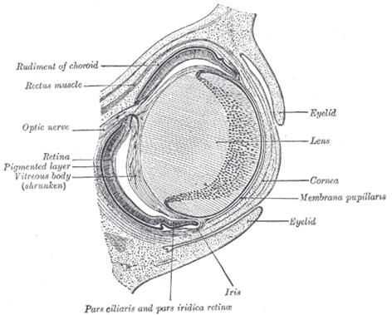
Horizontal section through the eye of an eighteen days’ embryo rabbit.

The vitreous body is developed between the lens and the optic cup. The lens rudiment and the optic vesicle are at first in contact with each other, but after the closure of the lens vesicle and the formation of the optic cup the former withdraws itself from the retinal layer of the cup; the two, however, remain connected by a network of delicate protoplasmic processes. This network, derived partly from the cells of the lens and partly from those of the retinal layer of the cup, constitutes the primitive vitreous body (867, 868). At first these protoplasmic processes spring from the whole of the retinal layer of the cup, but later are limited to the ciliary region, where by a process of condensation they appear to form the zonula ciliaris. The mesoderm which enters the cup through the choroidal fissure and around the equator of the lens becomes intimately united with this reticular tissue, and contributes to form the vitreous body, which is therefore derived partly from the ectoderm and partly from the mesoderm.
The anterior chamber of the eye appears as a cleft in the mesoderm separating the lens from the overlying ectoderm. The layer of mesoderm in front of the cleft forms the substantia propria of the cornea, that behind the cleft the stroma of the iris and the pupillary membrane. The fibers of the ciliary muscle are derived from the mesoderm, but those of the Sphincter and Dilatator pupillæ are of ectodermal origin, being developed from the cells of the pupillary part of the optic cup.
The sclera and choroid are derived from the mesoderm surrounding the optic cup.
The eyelids are formed as small cutaneous folds (866, 867), which about the middle of the third month come together and unite in front of the cornea. They remain united until about the end of the sixth month.

VIDEO

The lacrimal sac and nasolacrimal duct result from a thickening of the ectoderm in the groove, nasooptic furrow, between the lateral nasal and maxillary processes. This thickening forms a solid cord of cells which sinks into the mesoderm; during the third month the central cells of the cord break down, and a lumen, the nasolacrimal duct, is established. The lacrimal ducts arise as buds from the upper part of the cord of cells and secondarily establish openings (puncta lacrimalia) on the margins of the lids. The epithelium of the cornea and conjunctiva, and that which lines the ducts and alveoli of the lacrimal gland, are of ectodermal origin, as are also the eyelashes and the lining cells of the glands which open on the lid-margins.

THEME 2. ACCOMODATIVE APPARATUS ON OF THE EYEBALL. VISUAL ANALYZER PATHWAY. ACCESSORY STRUCTURES OF THE EYE: ORBITAL FASCIA, EYEBROWS, EYELIDS, CONJUCTIVA. LACRIMAL APPARATUS

There is ciliary muscle

in ciliary body, its contraction provides eye accommodation.
The refracting media are three, viz.:
Aqueous humor.
Vitreous body.
Crystalline lens.

The Aqueous Humor (humor aqueus).—The aqueous humor fills the anterior and posterior chambers of the eyeball. It is small in quantity, has an alkaline reaction, and consists mainly of water, less than one-fiftieth of its weight being solid matter, chiefly chloride of sodium.
The Vitreous Body (corpus vitreum).—The vitreous body forms about four-fifths of the bulb of the eye. It fills the concavity of the retina, and is hollowed in front, forming a deep concavity, the hyaloid fossa, for the reception of the lens. It is transparent, of the consistence of thin jelly, and is composed of an albuminous fluid enclosed in a delicate transparent membrane, the hyaloid membrane. It has been supposed, by Hannover, that from its surface numerous thin lamellæ are prolonged inward in a radiating manner, forming spaces in which the fluid is contained. In the adult, these lamellæ cannot be detected even after careful microscopic examination in the fresh state, but in preparations hardened in weak chromic acid it is possible to make out a distinct lamellation at the periphery of the body. In the center of the vitreous body, running from the entrance of the optic nerve to the posterior surface of the lens, is a canal, the hyaloid canal, filled with lymph and lined by a prolongation of the hyaloid membrane. This canal, in the embryonic vitreous body, conveyed the arteria hyaloidea from the central artery of the retina to the back of the lens. The fluid from the vitreous body is nearly pure water; it contains, however, some salts, and a little albumin.
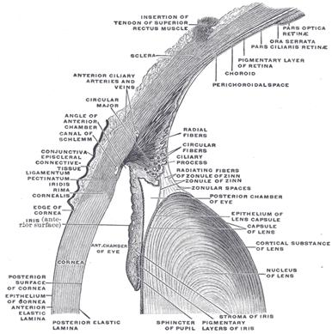
The hyaloid membrane envelopes the vitreous body. The portion in front of the ora serrata is thickened by the accession of radial fibers and is termed the zonula ciliaris (zonule of Zinn). Here it presents a series of radially arranged furrows, in which the ciliary processes are accommodated and to which they adhere, as is shown by the fact that when they are removed some of their pigment remains attached to the zonula. The zonula ciliaris splits into two layers, one of which is thin and lines the hyaloid fossa; the other is named the suspensory ligament of the lens: it is thicker, and passes over the ciliary body to be attached to the capsule of the lens a short distance in front of its equator. Scattered and delicate fibers are also attached to the region of the equator itself. This ligament retains the lens in position, and is relaxed by the contraction of the meridional fibers of the Ciliaris muscle, so that the lens is allowed to become more convex. Behind the suspensory ligament there is a sacculated canal, the spatia zonularis (canal of Petit), which encircles the equator of the lens; it can be easily inflated through a fine blowpipe inserted under the suspensory ligament.
No bloodvessels penetrate the vitreous body, so that its nutrition must be carried on by vessels of the retina and ciliary processes, situated upon its exterior.

video

The Crystalline Lens (lens crystallina).—The crystalline lens, enclosed in its capsule, is situated immediately behind the iris, in front of the vitreous body, and encircled by the ciliary processes, which slightly overlap its margin.
The capsule of the lens (capsula lentis) is a transparent, structureless membrane which closely surrounds the lens, and is thicker in front than behind. It is brittle but highly elastic, and when ruptured the edges roll up with the outer surface innermost. It rests, behind, in the hyaloid fossa in the forepart of the vitreous body; in front, it is in contact with the free border of the iris, but recedes from it at the circumference, thus forming the posterior chamber of the eye; it is retained in its position chiefly by the suspensory ligament of the lens, already described.
The lens is a transparent, biconvex body, the convexity of its anterior being less than that of its posterior surface. The central points of these surfaces are termed respectively the anterior and posterior poles; a line connecting the poles constitutes the axis of the lens, while the marginal circumference is termed the equator.

Structure.—The lens is made up of soft cortical substance and a firm, central part, the nucleus (884). Faint lines (radii lentis) radiate from the poles to the equator. In the adult there may be six or more of these lines, but in the fetus they are only three in number and diverge from each other at angles of 120° (885); on the anterior surface one line ascends vertically and the other two diverge downward; on the posterior surface one ray descends vertically and the other two diverge upward. They correspond with the free edges of an equal number of septa composed of an amorphous substance, which dip into the substance of the lens. When the lens has been hardened it is seen to consist of a series of concentrically arranged laminæ, each of which is interrupted at the septa referred to. Each lamina is built up of a number of hexagonal, ribbon-like lens fibers, the edges of which are more or less serrated—the serrations fitting between those of neighboring fibers, while the ends of the fibers come into apposition at the septa. The fibers run in a curved manner from the septa on the anterior surface to those on the posterior surface. No fibers pass from pole to pole; they are arranged in such a way that those which begin near the pole on one surface of the lens end near the peripheral extremity of the plane on the other, and vice versa. The fibers of the outer layers of the lens are nucleated, and together form a nuclear layer, most distinct toward the equator. The anterior surface of the lens is covered by a layer of transparent, columnar, nucleated epithelium. At the equator the cells become elongated, and their gradual transition into lens fibers can be traced (887).
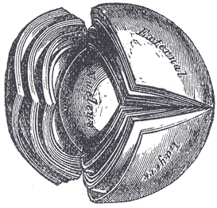
The crystalline lens, hardened and divided.
In the fetus, the lens is nearly spherical, and has a slightly reddish tint; it is soft and breaks down readily on the slightest pressure. A small branch from the arteria centralis retinæ runs forward, as already mentioned, through the vitreous body to the posterior part of the capsule of the lens, where its branches radiate and form a plexiform network, which covers the posterior surface of the capsule, and they are continuous around the margin of the capsule with the vessels of the pupillary membrane, and with those of the iris. In the adult, the lens is colorless, transparent, firm in texture, and devoid of vessels. In old age it becomes flattened on both surfaces, slightly opaque, of an amber tint, and increased in density (886).

Vessels and Nerves.—The arteries of the bulb of the eye are the long, short, and anterior ciliary arteries, and the arteria centralis retinæ. They have already been described (see p. 571).
The ciliary veins are seen on the outer surface of the choroid, and are named, from their arrangement, the venæ vorticosæ; they converge to four or five equidistant trunks which pierce the sclera midway between the sclero-corneal junction and the porus opticus. Another set of veins accompanies the anterior ciliary arteries. All of these veins open into the ophthalmic veins.
The ciliary nerves are derived from the nasociliary nerve and from the ciliary ganglion.

Additional eye structures include: extrinsic muscles of eyeball, eyebrows, eyelids, conjuctiva, lacrimal apparatus.
Extraocular Musculature
Levator palpebrae superioris
•Origin: inferior aspect of the lesser wing of sphenoid (adjacent to the common annular tendon) •Insertion:
1.medial and lateral walls of the orbit 2.superior tarsus
•Action: elevates the eyelid •Blood: branches of ophthalmic artery •Nerve: oculomotor nerve (III cranial)

Lateral rectus
•Origin:
1.common annular tendon (which comes off the body and lesser wing of sphenoid) 2.margins of the optic canal
•Insert: posterior to the sclerocorneal junction (each muscle inserting along its own directional axis) •Action: abducts eye •Blood: branches of ophthalmic artery •Nerve: abducens nerve (VI cranial)

Medial rectus
•Origin:
1.common annular tendon (which comes off the body and lesser wing of sphenoid) 2.margins of the optic canal
•Insert: posterior to the sclerocorneal junction (each muscle inserting along its own directional axis) •Action: adducts eye •Blood: branches of ophthalmic artery •Nerve: oculomotor nerve (III cranial)

Superior rectus
•Origin:
1.common annular tendon (which comes off the body and lesser wing of sphenoid) 2.margins of the optic canal
•Insert: posterior to the sclerocorneal junction (each muscle inserting along its own directional axis) •Action:
1.elevates 2.medially rotates 3.adducts the eye
•Blood: branches of ophthalmic artery •Nerve: oculomotor nerve (III cranial)

Superior rectus
•Origin:
1.common annular tendon (which comes off the body and lesser wing of sphenoid) 2.margins of the optic canal
•Insert: posterior to the sclerocorneal junction (each muscle inserting along its own directional axis) •Action:
1.elevates 2.medially rotates 3.adducts the eye
•Blood: branches of ophthalmic artery •Nerve: oculomotor nerve (III cranial)

Inferior rectus
•Origin:
1.common annular tendon (which comes off the body and lesser wing of sphenoid) 2.margins of the optic canal
•Insert: posterior to the sclerocorneal junction (each muscle inserting along its own directional axis) •Action:
1.depress 2.laterally rotates 3.adducts the eye
•Blood: branches of ophthalmic artery •Nerve: oculomotor nerve (III cranial)
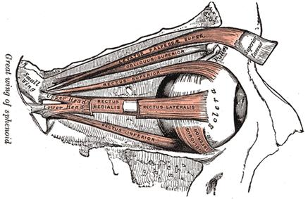
Superior oblique
•Origin: body of sphenoid •Insert: upper lateral quadrant of the posterior half of the sclera (via the trochlea, as a pulley) •Action:
1.depress 2.medially rotates 3.abducts the eye
•Blood: branches of ophthalmic artery •Nerve: trochlear nerve (IV cranial)

Inferior oblique
•Origin: orbital surface of maxilla •Insert: lower lateral quadrant of the posterior half of the sclera (via the suspensory ligament, as a pulley) •Action:
1.elevates 2.laterally rotates 3.abducts the eye
•Blood: branches of ophthalmic artery •Nerve: oculomotor nerve (III cranial)

Extrinsic ocular muscles subdivide into recti (straight) and oblique
Muscle
Rotation of eyeball
Cranial nerve innervation
Lateral rectus
Medial rectus
Superior rectus
Inferior rectus
Inferior oblique
Superior oblique
Lateral
Medial
Superior and medial
Inferior and medial
Superior and lateral
Inferior and lateral
Abducens (VI)
Oculomotor (III) - inferior branch
Oculomotor (III) - superior branch
Oculomotor (III) - inferior branch
Oculomotor (III) - inferior branch
Trochlear (IV)

They originate in common annular tendom and insert into sclera and can rotate eyeball on frontal and vertical axis. As result pupilla moves up, down laterally and medially. Superior oblique muscle psses through a pulleylike cartilagenous loop, the trochlea, before attaching to the eyeball. Levator palpebrae superioris muscle elevates upper eyelid.
Periosteum of orbit is ‘periorbita’ forming the cover of bones and passes through the optic canal into dura mater encephali. Eyeball is enveloped by vagina of eyeball (Tenon`s capsule). Adiposal body of orbit localised between vagina of eyeball and periorbita, which formes elastic pillow for eyeball.
Superior and inferior eyelids cover and protect eyeball. Front surface of eyelids is covered by skin. Posterior surface of the eyelids and anterior free surface of eyeball are covered by thin conjuctiva. Last forms superior and inferior sac of conjuctiva.
Tarsal plates, composed of dense regular connective tissue, are important in maintaining the shape of the eyelids. Yeybrows (supercilium) consist of short, sick hair positioned transversally above both eyes along the superior orbital ridges of the scull.
Lacrimal apparatus consists of lacrimal gland lying in superolateral portion of the orbit and a series of lacrimal ducts that drain the secretion into the nasal cavity. The excretory ductuli of lacrimal gland (10-15) open into conjuctival sac of upper yeylid (superior rivus). With each blink of the eyelids, tears passe medially and downward and drains into lake and two small openings, called lacrimal puncta on both sides of the lacrimal caruncle. From here, tears drains through the lacrimal canaliculus into the lacrimal sac and continious through the nasolacrimal duct to the inferior meatus of the nasal cavity.

Visual tract
Optic nerve is a part of visual analyser. Three neurons of visual tract are located in retina: 1 - fotoreceptors rods and cones, 2 – bipolar cells and 3 – ganglionic (multipolar) cells. Axons of third neurons form the II Optic nerve, which passes through the optic canal and get the cranial cavity. Medial fibres of the optic nerve pass to the opposite side and form the optic chiasma. Lateral fibres part do not cross each other and keep their own side. Then fibres of the optic nerve form optic tract wich get the subcortical sight centres (lateral geniculate body and superior colliculus of midbrain). Then 4th neurons are located under pulvinar thalami. Their axons run through the posterior leg of internal capsule (visual radiation) and reach cortical visual analyser in calcarine sulcus (occipital lobe).
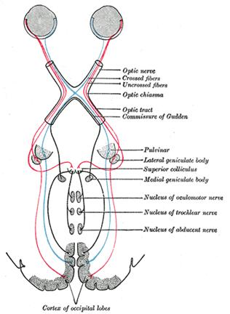
Axons of optic tract contact with cells in accessory oculomotor /parasympathetic/ nucleus (Yakubovych-Edinger-Westphal`s) by means of intermediate neuron. There are link for realising the pupillar reflex and accomodation. Axons of fifth neurons run in composition of oculomotor nerve get a ciliary ganglion, where sixth neurons positioned. Their axons pass with short ciliary nerves into eyeball and give innervating for ciliary and sphincter pupillae muscles. This reflex does not depend on our will and consciousness.

OLFACTORY ORGAN
Olfactory receptors placed in olfactory region of nasal cavity (in superior nasal meatus). Receptors (1st neuron) associated with epithelial supporting cells. The peripheral process of olfactory cells carry the olfactory cilia and the central process form 15-20 olfactory nerves (1st cranial nerve), which pass through the foramens in cribriform plate and reach the olfactory bulb. The axons of 2^{d} neurons runs through the olfactory tract terminate in olfactory triangle and anterior perforating substance, where the bodies of the 3^{d} neurons lie. Axons of the 3^{d} neurons get the uncus and other part of limbic system, which is cortical olfactory analyser.

TASTE ORGAN
In man gustatory buds (2000 in number) are situated in mucous membrane of the tongue, palatine, pharynx, epiglottis. Most of gustatory buds localised in vallatae, foliatae and fungiform papillae of the tongue. In front 2/3 part of tongue tasting impulses are perceived by fibres of chorda tympani (intermediate nerve), in back 1/3 portion of tongue – by glossopharyngeal nerve, in lingual root and epiglottis – by fibres of vagus nerve.
The central process of first neurons, that are situated in mouth cavity, pass in composition of VII, IX, X cranial nerves to tasting sensory nucleus that positioned in medulla oblongata - nucleus tractus solitarius. Axons of second neurons run to the thalamus, where the third neuron is situated. Axons of third neurons terminate in uncus (cortex of cerebrum), where is situated a cortical taste analyzer.

GENERAL COVER
Includes a skin and hypodermic stratum. Skin forms general bodies cover, which defends the organism from influence of external environment. It carries out regulation of warmly, metabolism, breathing, excretes the sweat and fat and is as depot of power resources. Skin is sensory organ and built from two layers:
1. epidermis (superficial layer);
2. dermis (deep layer, or proper skin), which consists of fibrous connective tissue, elastic and muscular fibers.
Blood and lymphatic capillaries, and terminal nervous bodies present in superior dermal layer. Lower stratum of dermis passes into hypodermic base where agglomeration of adipose cells is situated.
Skin color depends on pigment (melanin), which positioned in innermost layer of epidermis. Hair and nails derive from epidermis.
Hairs cover the skin (except palms, soles, transitional part of lips, head and preputium of penis, minor pudenda labia). Hair has a shaft and root. Last lies in deepness of skin and terminates by hair bulb, which provides growth of hair. Root of hair lies hair follicle where sebaceous gland opens and erector pili muscle attaches.
Nail is flattened elastic structures of a horny texture plate lying in connective tissue nail bed where it begins to growth. In nail there distinguish a nail root, nail body and free edge, which stick out form nail bed border, and also cover margin and lateral margin.
Skin Glands. Derivates of skin - sebaceous glands and sweat glands - are learned in histology course carefully.
Mammary gland is modified sweat gland, which lies on fascia of major pectoral muscle on level of the ІІІ-VІ ribs. Body of breasts consists of lobes of mammary gland, which contain 15-20 lobules of mammary gland, dissevered one from one by bands of connective tissue. The smallest lobules consist of a cluster of rounded alveoli, which open into the smallest branches of the lactiferous ducts; these ducts communicate by to form larger ducts, and these end in a single canal, corresponding with one of the chief subdivisions of the gland. They converge toward the areola, beneath which they form dilatations sinus, which serve as reservoirs for the milk, and, at the base of the papillæ. Lobes are disposed relatively to mammary nipple radially, and the mammary ducts open on the top of nipple. Mammary areola positioned round mammary nipple covered areolar tubercles where open areolar glands.

Hypodermic stratum contains nervous and venous plexus, lymphatic vessels and hypodermic adipose tissue, which carry out function of thermal isolation and depot of energetic reserve.
Also a soft connective tissue there is situated.

Prepared by Boymystruk I.I.

