THEME 3. ORGANS OF HEARING AND EQUILIBRIUM. STRUCTURE OF OUTER AND MIDDLE EAR
EAR (HEARING AND EQUILIBRIUM ORGAN)
Ear subdivides on auricle (outer ear), middle ear and internal ear. Auricle and external auditory meatus belong to outer ear. Middle ear contains a tympanic cavity and auditory tube (Eustachian). Internal ear composes an osseous labyrinth and membranous labyrinth.
AURICLE contains a cartilage covered by skin. In inferior part a cartilage is absent there is auricular lobule (earlobe). Also auricle has a helix, triangular fossa, antihelix, concha, tragus, antitragus.
External auditory meatus is open outside, in depth from cavity of middle ear it dissociates by tympanic membrane. External auditory meatus has cartilaginous part and inner osseous part. Cartilaginous part composes one-third length of auditory meatus. Osseous part occupies two thirds of auditory meatus. Auditory meatus is curved S-like and for its straightening attached to examination of tympanic membrane necessary to draw off auricle posterior, up and outside.
The external ear consists of the expanded portion named the auricula or pinna, and the external acoustic meatus. The former projects from the side of the head and serves to collect the vibrations of the air by which sound is produced; the latter leads inward from the bottom of the auricula and conducts the vibrations to the tympanic cavity.
The Auricula or Pinna (904) is of an ovoid form, with its larger end directed upward. Its lateral surface is irregularly concave, directed slightly forward, and presents numerous eminences and depressions to which names have been assigned. The prominent rim of the auricula is called the helix; where the helix turns downward behind, a small tubercle, the auricular tubercle of Darwin, is frequently seen; this tubercle is very evident about the sixth month of fetal life when the whole auricula has a close resemblance to that of some of the adult monkeys. Another curved prominence, parallel with and in front of the helix, is called the antihelix; this divides above into two crura, between which is a triangular depression, the fossa triangularis. The narrow-curved depression between the helix and the antihelix is called the scapha; the antihelix describes a curve around a deep, capacious cavity, the concha, which is partially divided into two parts by the crus or commencement of the helix; the upper part is termed the cymba conchæ, the lower part the cavum conchæ. In front of the concha, and projecting backward over the meatus, is a small pointed eminence, the tragus, so called from its being generally covered on its under surface with a tuft of hair, resembling a goat’s beard. Opposite the tragus, and separated from it by the intertragic notch, is a small tubercle, the antitragus. Below this is the lobule, composed of tough areolar and adipose tissues, and wanting the firmness and elasticity of the rest of the auricula.
The cranial surface of the auricula presents elevations which correspond to the depressions on its lateral surface and after which they are named, e. g., eminentia conchæ, eminentia triangularis, etc.
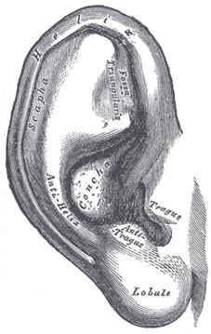
The auricula. Lateral surface.
Structure.—The auricula is composed of a thin plate of yellow fibrocartilage, covered with integument, and connected to the surrounding parts by ligaments and muscles; and to the commencement of the external acoustic meatus by fibrous tissue.
The skin is thin, closely adherent to the cartilage, and covered with fine hairs furnished with sebaceous glands, which are most numerous in the concha and scaphoid fossa. On the tragus and antitragus the hairs are strong and numerous. The skin of the auricula is continuous with that lining the external acoustic meatus.
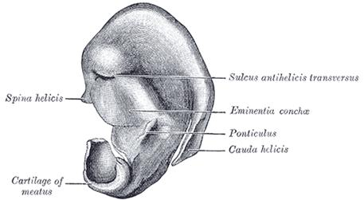
Cranial surface of cartilage of right auricula.
The cartilage of the auricula (cartilago auriculæ; cartilage of the pinna) (905, 906) consists of a single piece; it gives form to this part of the ear, and upon its surface are found the eminences and depressions above described. It is absent from the lobule; it is deficient, also, between the tragus and beginning of the helix, the gap being filled up by dense fibrous tissue. At the front part of the auricula, where the helix bends upward, is a small projection of cartilage, called the spina helicis, while in the lower part of the helix the cartilage is prolonged downward as a tail-like process, the cauda helicis; this is separated from the antihelix by a fissure, the fissura antitragohelicina. The cranial aspect of the cartilage exhibits a transverse furrow, the sulcus antihelicis transversus, which corresponds with the inferior crus of the antihelix and separates the eminentia conchæ from the eminentia triangularis. The eminentia conchæ is crossed by a vertical ridge (ponticulus), which gives attachment to the Auricularis posterior muscle. In the cartilage of the auricula are two fissures, one behind the crus helicis and another in the tragus.
The ligaments of the auricula (ligamenti auricularia [Valsalva]; ligaments of the pinna) consist of two sets: (1) extrinsic, connecting it to the side of the head; (2) intrinsic, connecting various parts of its cartilage together.
The extrinsic ligaments are two in number, anterior and posterior. The anterior ligament extends from the tragus and spina helicis to the root of the zygomatic process of the temporal bone. The posterior ligament passes from the posterior surface of the concha to the outer surface of the mastoid process.
The chief intrinsic ligaments are: (a) a strong fibrous band, stretching from the tragus to the commencement of the helix, completing the meatus in front, and partly encircling the boundary of the concha; and (b) a band between the antihelix and the cauda helicis. Other less important bands are found on the cranial surface of the pinna.
The muscles of the auricula (906) consist of two sets: (1) the extrinsic, which connect it with the skull and scalp and move the auricula as a whole; and (2) the intrinsic, which extend from one part of the auricle to another.
The extrinsic muscles are the Auriculares anterior, superior, and posterior.
The Auricularis anterior (Attrahens aurem), the smallest of the three, is thin, fan-shaped, and its fibers are pale and indistinct. It arises from the lateral edge of the galea aponeurotica, and its fibers converge to be inserted into a projection on the front of the helix.
The Auricularis superior (Attolens aurem), the largest of the three, is thin and fan-shaped. Its fibers arise from the galea aponeurotica, and converge to be inserted by a thin, flattened tendon into the upper part of the cranial surface of the auricula.
The Auricularis posterior (Retrahens aurem) consists of two or three fleshy fasciculi, which arise from the mastoid portion of the temporal bone by short aponeurotic fibers. They are inserted into the lower part of the cranial surface of the concha.
Actions.—In man, these muscles possess very little action: the Auricularis anterior draws the auricula forward and upward; the Auricularis superior slightly raises it; and the Auricularis posterior draws it backward.
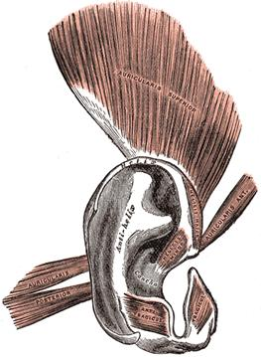
The muscles of the auricula.

VIDEO
The intrinsic muscles are the:
Helicis major.
Antitragicus.
Helicis minor.
Transversus auriculæ.
Tragicus.
Obliquus auriculæ.
The Helicis major is a narrow vertical band situated upon the anterior margin of the helix.
It arises below, from the spina helicis, and is inserted into the anterior border of the helix, just where it is about to curve backward.
The Helicis minor is an oblique fasciculus, covering the crus helicis.
The Tragicus is a short, flattened vertical band on the lateral surface of the tragus.
The Antitragicus arises from the outer part of the antitragus, and is inserted into the cauda helicis and antihelix.
The Transversus auriculæ is placed on the cranial surface of the pinna. It consists of scattered fibers, partly tendinous and partly muscular, extending from the eminentia conchæ to the prominence corresponding with the scapha.
The Obliquus auriculæ, also on the cranial surface, consists of a few fibers extending from the upper and back part of the concha to the convexity immediately above it.
Nerves.—The Auriculares anterior and superior and the intrinsic muscles on the lateral surface are supplied by the temporal branch of the facial nerve, the Auricularis posterior and the intrinsic muscles on the cranial surface by the posterior auricular branch of the same nerve.
The arteries of the auricula are the posterior auricular from the external carotid, the anterior auricular from the superficial temporal, and a branch from the occipital artery.
The veins accompany the corresponding arteries.
The sensory nerves are: the great auricular, from the cervical plexus; the auricular branch of the vagus; the auriculotemporal branch of the mandibular nerve; and the lesser occipital from the cervical plexus.
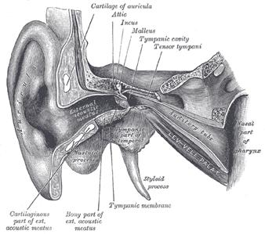
External and middle ear, opened from the front. Right side.
The External Acoustic Meatus (meatus acusticus externus; external auditory canal or meatus) extends from the bottom of the concha to the tympanic membrane (907, 908). It is about 4 cm. in length if measured from the tragus; from the bottom of the concha its length is about 2.5 cm. It forms an S-shaped curve, and is directed at first inward, forward, and slightly upward (pars externa); it then passes inward and backward (pars media), and lastly is carried inward, forward, and slightly downward (pars interna). It is an oval cylindrical canal, the greatest diameter being directed downward and backward at the external orifice, but nearly horizontally at the inner end. It presents two constrictions, one near the inner end of the cartilaginous portion, and another, the isthmus, in the osseous portion, about 2 cm. from the bottom of the concha. The tympanic membrane, which closes the inner end of the meatus, is obliquely directed; in consequence of this the floor and anterior wall of the meatus are longer than the roof and posterior wall.
The external acoustic meatus is formed partly by cartilage and membrane, and partly by bone, and is lined by skin.
The cartilaginous portion (meatus acusticus externus cartilagineus) is about 8 mm. in length; it is continuous with the cartilage of the auricula, and firmly attached to the circumference of the auditory process of the temporal bone. The cartilage is deficient at the upper and back part of the meatus, its place being supplied by fibrous membrane; two or three deep fissures are present in the anterior part of the cartilage.
The osseous portion (meatus acusticus externus osseus) is about 16 mm. in length, and is narrower than the cartilaginous portion. It is directed inward and a little forward, forming in its course a slight curve the convexity of which is upward and backward. Its inner end is smaller than the outer, and sloped, the anterior wall projecting beyond the posterior for about 4 mm.; it is marked, except at its upper part, by a narrow groove, the tympanic sulcus, in which the circumference of the tympanic membrane is attached. Its outer end is dilated and rough in the greater part of its circumference, for the attachment of the cartilage of the auricula. The front and lower parts of the osseous portion are formed by a curved plate of bone, the tympanic part of the temporal, which, in the fetus, exists as a separate ring (annulus tympanicus,) incomplete at its upper part (page 146).
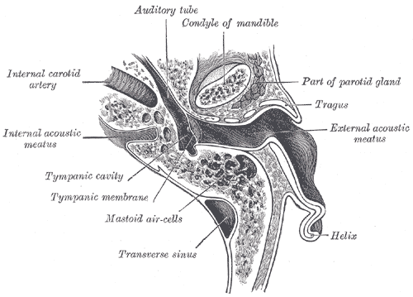
Horizontal section through left ear; upper half of section.
The skin lining the meatus is very thin; adheres closely to the cartilaginous and osseous portions of the tube, and covers the outer surface of the tympanic membrane. After maceration, the thin pouch of epidermis, when withdrawn, preserves the form of the meatus. In the thick subcutaneous tissue of the cartilaginous part of the meatus are numerous ceruminous glands, which secrete the ear-wax; their structure resembles that of the sudoriferous glands.

Relations of the Meatus.—In front of the osseous part is the condyle of the mandible, which however, is frequently separated from the cartilaginous part by a portion of the parotid gland. The movements of the jaw influence to some extent the lumen of this latter portion. Behind the osseous part are the mastoid air cells, separated from the meatus by a thin layer of bone.
The arteries supplying the meatus are branches from the posterior auricular, internal maxillary, and temporal.
The nerves are chiefly derived from the auriculotemporal branch of the mandibular nerve and the auricular branch of the vagus.

Tympanic cavity positioned in thickness of temporal pyramid and has the following walls:
1. tegmental wall (superior);
2. jugular wall (inferior);
3. labyrinthic wall (medial), where found 2 windows: vestibular (oval) window and cochlear (round) window. Vestibular window is closed by base stapes. Round window is tightened by secondary tympanic membrane;
4. mastoid wall (posterior). On it located stapedius muscle. Superiorly posterior wall continues into mastoid cave, the mastoid cells open in it;
5. carotid wall (anterior), a tympanic foramen of auditory tube and muscle-tensor of tympanic membrane are found here;
6. membranous wall (lateral) is formed tympanic membrane. Epitympanic recess contains a head of malleus and body of the incus.
The middle ear or tympanic cavity is an irregular, laterally compressed space within the temporal bone. It is filled with air, which is conveyed to it from the nasal part of the pharynx through the auditory tube. It contains a chain of movable bones, which connect its lateral to its medial wall, and serve to convey the vibrations communicated to the tympanic membrane across the cavity to the internal ear.
The tympanic cavity consists of two parts: the tympanic cavity proper, opposite the tympanic membrane, and the attic or epitympanic recess, above the level of the membrane; the latter contains the upper half of the malleus and the greater part of the incus. Including the attic, the vertical and antero-posterior diameters of the cavity are each about 15 mm. The transverse diameter measures about 6 mm. above and 4 mm. below; opposite the center of the tympanic membrane it is only about 2 mm. The tympanic cavity is bounded laterally by the tympanic membrane; medially, by the lateral wall of the internal ear; it communicates, behind, with the tympanic antrum and through it with the mastoid air cells, and in front with the auditory tube (907).
The Tegmental Wall or Roof (paries tegmentalis) is formed by a thin plate of bone, the tegmen tympani, which separates the cranial and tympanic cavities. It is situated on the anterior surface of the petrous portion of the temporal bone close to its angle of junction with the squama temporalis; it is prolonged backward so as to roof in the tympanic antrum, and forward to cover in the semicanal for the Tensor tympani muscle. Its lateral edge corresponds with the remains of the petrosquamous suture.
The Jugular Wall or Floor (paries jugularis) is narrow, and consists of a thin plate of bone (fundus tympani) which separates the tympanic cavity from the jugular fossa. It presents, near the labyrinthic wall, a small aperture for the passage of the tympanic branch of the glossopharyngeal nerve.
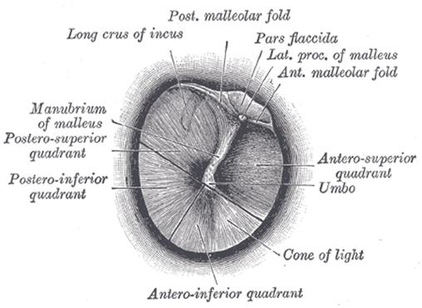
Right tympanic membrane as seen through a speculum.
The Membranous or Lateral Wall (paries membranacea; outer wall) is formed mainly by the tympanic membrane, partly by the ring of bone into which this membrane is inserted. This ring of bone is incomplete at its upper part, forming a notch (notch of Rivinus), close to which are three small apertures: the iter chordæ posterius, the petrotympanic fissure, and the iter chordæ anterius.
The iter chordæ posterius (apertura tympanica canaliculi chordæ) is situated in the angle of junction between the mastoid and membranous wall of the tympanic cavity immediately behind the tympanic membrane and on a level with the upper end of the manubrium of the malleus; it leads into a minute canal, which descends in front of the canal for the facial nerve, and ends in that canal near the stylo-mastoid foramen. Through it the chorda tympani nerve enters the tympanic cavity.
The petrotympanic fissure (fissura petrotympanica; Glaserian fissure) opens just above and in front of the ring of bone into which the tympanic membrane is inserted; in this situation it is a mere slit about 2 mm. in length. It lodges the anterior process and anterior ligament of the malleus, and gives passage to the anterior tympanic branch of the internal maxillary artery.
The iter chordæ anterius (canal of Huguier) is placed at the medial end of the petrotympanic fissure; through it the chorda tympani nerve leaves the tympanic cavity.
The Tympanic Membrane (membrana tympani) (909, 910) separates the tympanic cavity from the bottom of the external acoustic meatus. It is a thin, semitransparent membrane, nearly oval in form, somewhat broader above than below, and directed very obliquely downward and inward so as to form an angle of about fifty-five degrees with the floor of the meatus. Its longest diameter is downward and forward, and measures from 9 to 10 mm.; its shortest diameter measures from 8 to 9 mm. The greater part of its circumference is thickened, and forms a fibrocartilaginous ring which is fixed in the tympanic sulcus at the inner end of the meatus. This sulcus is deficient superiorly at the notch of Rivinus, and from the ends of this notch two bands, the anterior and posterior malleolar folds, are prolonged to the lateral process of the malleus. The small, somewhat triangular part of the membrane situated above these folds is lax and thin, and is named the pars flaccida; in it a small orifice is sometimes seen. The manubrium of the malleus is firmly attached to the medial surface of the membrane as far as its center, which it draws toward the tympanic cavity; the lateral surface of the membrane is thus concave, and the most depressed part of this concavity is named the umbo.
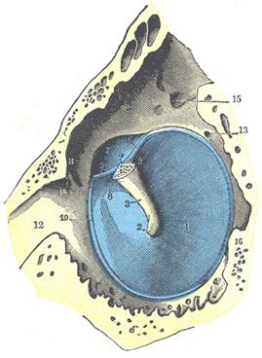
The tympanic membrane viewed from within. (Testut.) The malleus has been resected immediately beyond its lateral process, in order to show the tympanomalleolar folds and the membrana flaccida. 1. Tympanic membrane. 2. Umbo. 3. Handle of the malleus. 4. Lateral process. 5. Anterior tympanomalleolar fold. 6. Posterior tympanomalleolar fold. 7. Pars flaccida. 8. Anterior pouch of Tröltsch. 9. Posterior pouch of Tröltsch. 10. Fibrocartilaginous ring. 11. Petrotympanic fissure. 12. Auditory tube. 13. Iter chordæ posterius. 14. Iter chordæ anterius. 15. Fossa incudis for short crus of the incus. 16. Prominentia styloidea.
Structure.—The tympanic membrane is composed of three strata: a lateral (cutaneous), an intermediate (fibrous), and a medial (mucous). The cutaneous stratum is derived from the integument lining the meatus. The fibrous stratum consists of two layers: a radiate stratum, the fibers of which diverge from the manubrium of the malleus, and a circular stratum, the fibers of which are plentiful around the circumference but sparse and scattered near the center of the membrane. Branched or dendritic fibers, as pointed out by Grüber, are also present especially in the posterior half of the membrane.

Vessels and Nerves.—The arteries of the tympanic membrane are derived from the deep auricular branch of the internal maxillary, which ramifies beneath the cutaneous stratum; and from the stylomastoid branch of the posterior auricular, and tympanic branch of the internal maxillary, which are distributed on the mucous surface. The superficial veins open into the external jugular; those on the deep surface drain partly into the transverse sinus and veins of the dura mater, and partly into a plexus on the auditory tube. The membrane receives its chief nerve supply from the auriculotemporal branch of the mandibular; the auricular branch of the vagus, and the tympanic branch of the glossopharyngeal also supply it. 150
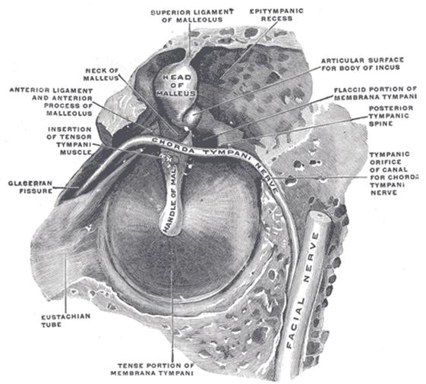
The right membrana tympani with the hammer and the chorda tympani, viewed from within, from behind, and from above.

VIDEO

The Labyrinthic or Medial Wall (paries labyrinthica; inner wall) (913) is vertical in direction, and presents for examination the fenestræ vestibuli and cochleæ, the promontory, and the prominence of the facial canal.
The fenestra vestibuli (fenestra ovalis) is a reniform opening leading from the tympanic cavity into the vestibule of the internal ear; its long diameter is horizontal, and its convex border is upward. In the recent state it is occupied by the base of the stapes, the circumference of which is fixed by the annular ligament to the margin of the foramen.
The fenestra cochleæ (fenestra rotunda) is situated below and a little behind the fenestra vestibuli, from which it is separated by a rounded elevation, the promontory. It is placed at the bottom of a funnel-shaped depression and, in the macerated bone, leads into the cochlea of the internal ear; in the fresh state it is closed by a membrane, the secondary tympanic membrane, which is concave toward the tympanic cavity, convex toward the cochlea. This membrane consists of three layers: an external, or mucous, derived from the mucous lining of the tympanic cavity; an internal, from the lining membrane of the cochlea; and an intermediate, or fibrous layer.
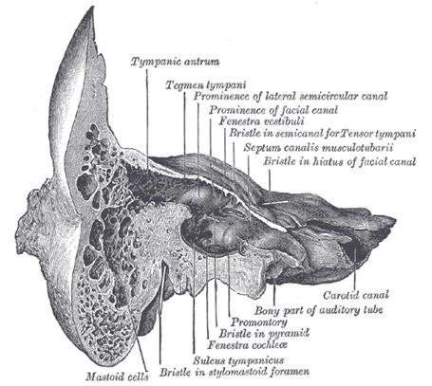
Coronal section of right temporal bone.

The promontory (promontorium) is a rounded hollow prominence, formed by the projection outward of the first turn of the cochlea; it is placed between the fenestræ, and is furrowed on its surface by small grooves, for the lodgement of branches of the tympanic plexus. A minute spicule of bone frequently connects the promontory to the pyramidal eminence.
The prominence of the facial canal (prominentia canalis facialis; prominence of aqueduct of Fallopius) indicates the position of the bony canal in which the facial nerve is contained; this canal traverses the labyrinthic wall of the tympanic cavity above the fenestra vestibuli, and behind that opening curves nearly vertically downward along the mastoid wall.
The mastoid or posterior wall (paries mastoidea) is wider above than below, and presents for examination the entrance to the tympanic antrum, the pyramidal eminence, and the fossa incudis.
The entrance to the antrum is a large irregular aperture, which leads backward from the epitympanic recess into a considerable air space, named the tympanic or mastoid antrum (see page 142). The antrum communicates behind and below with the mastoid air cells, which vary considerably in number, size, and form; the antrum and mastoid air cells are lined by mucous membrane, continuous with that lining the tympanic cavity. On the medial wall of the entrance to the antrum is a rounded eminence, situated above and behind the prominence of the facial canal; it corresponds with the position of the ampullated ends of the superior and lateral semicircular canals.
The pyramidal eminence (eminentia pyramidalis; pyramid) is situated immediately behind the fenestra vestibuli, and in front of the vertical portion of the facial canal; it is hollow, and contains the Stapedius muscle; its summit projects forward toward the fenestra vestibuli, and is pierced by a small aperture which transmits the tendon of the muscle. The cavity in the pyramidal eminence is prolonged downward and backward in front of the facial canal, and communicates with it by a minute aperture which transmits a twig from the facial nerve to the Stapedius muscle.
The fossa incudis is a small depression in the lower and back part of the epitympanic recess; it lodges the short crus of the incus.
The Carotid or Anterior Wall (paries carotica) is wider above than below; it corresponds with the carotid canal, from which it is separated by a thin plate of bone perforated by the tympanic branch of the internal carotid artery, and by the deep petrosal nerve which connects the sympathetic plexus on the internal carotid artery with the tympanic plexus on the promontory. At the upper part of the anterior wall are the orifice of the semicanal for the Tensor tympani muscle and the tympanic orifice of the auditory tube, separated from each other by a thin horizontal plate of bone, the septum canalis musculotubarii. These canals run from the tympanic cavity forward and downward to the retiring angle between the squama and the petrous portion of the temporal bone.
The semicanal for the Tensor tympani (semicanalis m. tensoris tympani) is the superior and the smaller of the two; it is cylindrical and lies beneath the tegmen tympani. It extends on to the labyrinthic wall of the tympanic cavity and ends immediately above the fenestra vestibuli.
The septum canalis musculotubarii (processus cochleariformis) passes backward below this semicanal, forming its lateral wall and floor; it expands above the anterior end of the fenestra vestibuli and terminates there by curving laterally so as to form a pulley over which the tendon of the muscle passes.
The auditory tube (tuba auditiva; Eustachian tube) is the channel through which the tympanic cavity communicates with the nasal part of the pharynx. Its length is about 36 mm., and its direction is downward, forward, and medialward, forming an angle of about 45 degrees with the sagittal plane and one of from 30 to 40 degrees with the horizontal plane. It is formed partly of bone, partly of cartilage and fibrous tissue (819, 915).
The osseous portion (pars osseo tubæ auditivæ) is about 12 mm. in length. It begins in the carotid wall of the tympanic cavity, below the septum canalis musculotubarii, and, gradually narrowing, ends at the angle of junction of the squama and the petrous portion of the temporal bone, its extremity presenting a jagged margin which serves for the attachment of the cartilaginous portion.
The cartilaginous portion (pars cartilaginea tubæ auditivæ), about 24 mm. in length, is formed of a triangular plate of elastic fibrocartilage, the apex of which is attached to the margin of the medial end of the osseous portion of the tube, while its base lies directly under the mucous membrane of the nasal part of the pharynx, where it forms an elevation, the torus tubarius or cushion, behind the pharyngeal orifice of the tube. The upper edge of the cartilage is curled upon itself, being bent laterally so as to present on transverse section the appearance of a hook; a groove or furrow is thus produced, which is open below and laterally, and this part of the canal is completed by fibrous membrane. The cartilage lies in a groove between the petrous part of the temporal and the great wing of the sphenoid; this groove ends opposite the middle of the medial pterygoid plate. The cartilaginous and bony portions of the tube are not in the same plane, the former inclining downward a little more than the latter. The diameter of the tube is not uniform throughout, being greatest at the pharyngeal orifice, least at the junction of the bony and cartilaginous portions, and again increased toward the tympanic cavity; the narrowest part of the tube is termed the isthmus. The position and relations of the pharyngeal orifice are described with the nasal part of the pharynx. The mucous membrane of the tube is continuous in front with that of the nasal part of the pharynx, and behind with that of the tympanic cavity; it is covered with ciliated epithelium and is thin in the osseous portion, while in the cartilaginous portion it contains many mucous glands and near the pharyngeal orifice a considerable amount of adenoid tissue, which has been named by Gerlach the tube tonsil. The tube is opened during deglutition by the Salpingopharyngeus and Dilatator tubæ. The latter arises from the hook of the cartilage and from the membranous part of the tube, and blends below with the Tensor veli palatini.

Three auditory ossicles (malleus, incus and stapes), and two muscles are placed in tympanic cavity. Malleus has a head and manubrium with anterior and lateral processes. Muscle-tensor of tympanic membrane handle fastened to malleus. Incus consists of body, short and long legs. Body of incus adjoins to head of malleus, forming incusоmalleus jont. Long leg unites with stapes. Stapes has a head, anterior leg and posterior leg and base stapes, which closes a vestibular window. Musculus stapedius fastens to posterior leg of stapes. Muscles of tympanic cavity regulate auditory ossicles and prevent their oscillation during loud sounds.

STRUCTURE OF INTERNAL EAR. HEARING ANALYZER PATHWAY. ORGANS OF SMELL AND TASTE, PATHWAYS. STRUCTURE OF SKIN
Osseous labyrinth consists of cochlea, vestibulum and semicircular canals.
Vestibulum represents by cavity, its lateral wall carries vestibular and cochlear fenestrae (windows). Vestibular (oval) fenestra containes a base of stapes, and a cochlear (round) window is closed by the secondary tympanic membrane. There are 5 foramens of the semicircle canals in posterior wall of vestibulum, anterior wall has a big foramen conducting into cochlear canal. Crest of internal wall separates a spherical recess from elliptic recess. Internal foramen of vestibular canalicule opens in elliptic recess.
Osseous semicircular canals represented by three arched tubes lying in three mutually perpendicular planes. There are anterior, posterior and lateral semicircular canals. Each semicircular canal has broadened part in its base anterior, posterior and lateral osseous ampule. Semicircle canals join the vestibulum by the medium of osseous legs. Those legs containing ampule are called ampular legs. The legs of the anterior and posterior semicircular canal fuse together into one. As result the semicircle osseous canals unite with vestibulum by five foramina.
Cochlea (snail shell) lies anteriorly from vestibulum, represented by osseous tube forming two and half turns round cochlear axis (modiolus). There is osseous spiral plate inside the cochlea, apex of the cochlea called cupula. In cochlear base internal foramen of cochlear canaliculi is found.
Membranous labyrinth is inserted in osseous labyrinth, has the lesser dimensions and repeats the course of osseous labyrinth. The perilymphatic space is situated between internal surface of osseous labyrinth and external surface of membranous one and filled with liquid - perilymph. Membranous labyrinth is filled with the endolymph. Membranous labyrinth consists of vestibular part (a), semicircular canals (b) and cochlear duct (c).
A. Vestibular labyrinth consists of utriculus and sacculus. Utriculus lies in elliptic recess of osseous labyrinth and connects with semicircular ducts, and a sacculus lies in spherical recess of osseous labyrinth and connects with cochlear duct by communicating duct. Utriculus and saccule communicate each other by the medium of utriculosaccular duct. From last endolymphatic duct starts that passes in vestibular canalicule. Endolymphatic duct passing from external foramen of vestibular canaliculus on posterior surface of pyramide of temporal bone, reaches endolymphatic sacculus placed under cerebral dura mater.
B. Semicircular ducts are inserted in osseous semicircular canals. So there are anterior, posterior and lateral semicircular ducts. They carry anterior, posterior and lateral membranous ampulae. Receptors of balance of rotating located in cristae ampullares. Receptors of balance located in static maculae in utriculus and sacculus.
C. Cochlear duct positioned in spiral canal and starts from vestibular osseous labyrinth and finishes in blind end. On transversal cut a cochlear duct has triangle shape and enclosed by external, superior and inferior walls. External wall fused together with periosteum of spiral canal; an inferior wall is a tympanic wall, it supplementes the spiral plate; superior wall is vestibular wall. Cochlear duct occupies middle part of osseous spiral canal and separates tympanic scala from vestibular scala. Spiral organ (Corti) localised in cochlear duct on spiral membrane, which belongs to peripheral part of auditory analyser.
Sound waves are received by tympanic membrane from auricle and external acoustic meatus. Oscillation of tympanic membrane is transfered to auditory ossicles - malleus, incus and stapes. Base of stapes, which covers a window vestibularа, begins oscillates the perilymph. Oscillation passes through vestibular scala, helicotrema and tympanic scala. Then vestibular wall (Reisner`s membrane) starts to vibrate. Last forces the oscillation of the endolymph in cochlear duct. This vibration is received by sensory haircells of spiral (Korti) organ.
The internal ear is the essential part of the organ of hearing, receiving the ultimate distribution of the auditory nerve. It is called the labyrinth, from the complexity of its shape, and consists of two parts: the osseous labyrinth, a series of cavities within the petrous part of the temporal bone, and the membranous labyrinth, a series of communicating membranous sacs and ducts, contained within the bony cavities.
The Vestibule (vestibulum).—The vestibule is the central part of the osseous labyrinth, and is situated medial to the tympanic cavity, behind the cochlea, and in front of the semicircular canals. It is somewhat ovoid in shape, but flattened transversely; it measures about 5 mm. from before backward, the same from above downward, and about 3 mm. across. In its lateral or tympanic wall is the fenestra vestibuli, closed, in the fresh state, by the base of the stapes and annular ligament. On its medial wall, at the forepart, is a small circular depression, the recessus sphæricus, which is perforated, at its anterior and inferior part, by several minute holes (macula cribrosa media) for the passage of filaments of the acoustic nerve to the saccule; and behind this depression is an oblique ridge, the crista vestibuli, the anterior end of which is named the pyramid of the vestibule. This ridge bifurcates below to enclose a small depression, the fossa cochlearis, which is perforated by a number of holes for the passage of filaments of the acoustic nerve which supply the vestibular end of the ductus cochlearis. As the hinder part of the medial wall is the orifice of the aquæductus vestibuli, which extends to the posterior surface of the petrous portion of the temporal bone. It transmits a small vein, and contains a tubular prolongation of the membranous labyrinth, the ductus endolymphaticus, which ends in a cul-de-sac between the layers of the dura mater within the cranial cavity. On the upper wall or roof is a transversely oval depression, the recessus ellipticus, separated from the recessus sphæricus by the crista vestibuli already mentioned. The pyramid and adjoining part of the recessus ellipticus are perforated by a number of holes (macula cribrosa superior). The apertures in the pyramid transmit the nerves to the utricle; those in the recessus ellipticus the nerves to the ampullæ of the superior and lateral semicircular ducts. Behind are the five orifices of the semicircular canals. In front is an elliptical opening, which communicates with the scala vestibuli of the cochlea.
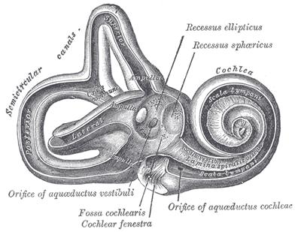
Interior of right osseous labyrinth.
The Bony Semicircular Canals (canales semicirculares ossei).—The bony semicircular canals are three in number, superior, posterior, and lateral, and are situated above and behind the vestibule. They are unequal in length, compressed from side to side, and each describes the greater part of a circle. Each measures about 0.8 mm. in diameter, and presents a dilatation at one end, called the ampulla, which measures more than twice the diameter of the tube. They open into the vestibule by five orifices, one of the apertures being common to two of the canals.
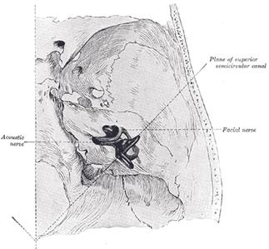
Position of the right bony labyrinth of the ear in the skull, viewed from above. The temporal bone is considered transparent and the labyrinth drawn in from a corrosion preparation.

The superior semicircular canal (canalis semicircularis superior), 15 to 20 mm. in length, is vertical in direction, and is placed transversely to the long axis of the petrous portion of the temporal bone, on the anterior surface of which its arch forms a round projection. It describes about two-thirds of a circle. Its lateral extremity is ampullated, and opens into the upper part of the vestibule; the opposite end joins with the upper part of the posterior canal to form the crus commune, which opens into the upper and medial part of the vestibule.
The posterior semicircular canal (canalis semicircularis posterior), also vertical, is directed backward, nearly parallel to the posterior surface of the petrous bone; it is the longest of the three, measuring from 18 to 22 mm.; its lower or ampullated end opens into the lower and back part of the vestibule, its upper into the crus commune already mentioned.
The lateral or horizontal canal (canalis semicircularis lateralis; external semicircular canal) is the shortest of the three. It measures from 12 to 15 mm., and its arch is directed horizontally backward and lateralward; thus each semicircular canal stands at right angles to the other two. Its ampullated end corresponds to the upper and lateral angle of the vestibule, just above the fenestra vestibuli, where it opens close to the ampullated end of the superior canal; its opposite end opens at the upper and back part of the vestibule. The lateral canal of one ear is very nearly in the same plane as that of the other; while the superior canal of one ear is nearly parallel to the posterior canal of the other.
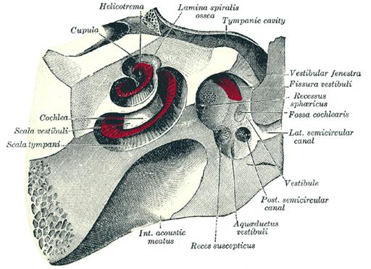
The cochlea and vestibule, viewed from above. All the hard parts which form the roof of the internal ear have been removed with the saw.

The Cochlea (922, 923).—The cochlea bears some resemblance to a common snail-shell; it forms the anterior part of the labyrinth, is conical in form, and placed almost horizontally in front of the vestibule; its apex (cupula) is directed forward and lateralward, with a slight inclination downward, toward the upper and front part of the labyrinthic wall of the tympanic cavity; its base corresponds with the bottom of the internal acoustic meatus, and is perforated by numerous apertures for the passage of the cochlear division of the acoustic nerve. It measures about 5 mm. from base to apex, and its breadth across the base is about 9 mm. It consists of a conical shaped central axis, the modiolus; of a canal, the inner wall of which is formed by the central axis, wound spirally around it for two turns and three-quarters, from the base to the apex; and of a delicate lamina, the osseous spiral lamina, which projects from the modiolus, and, following the windings of the canal, partially subdivides it into two. In the recent state a membrane, the basilar membrane, stretches from the free border of this lamina to the outer wall of the bony cochlea and completely separates the canal into two passages, which, however, communicate with each other at the apex of the modiolus by a small opening named the helicotrema.
The modiolus is the conical central axis or pillar of the cochlea. Its base is broad, and appears at the bottom of the internal acoustic meatus, where it corresponds with the area cochleæ; it is perforated by numerous orifices, which transmit filaments of the cochlear division of the acoustic nerve; the nerves for the first turn and a half pass through the foramina of the tractus spiralis foraminosus; those for the apical turn, through the foramen centrale. The canals of the tractus spiralis foraminosus pass up through the modiolus and successively bend outward to reach the attached margin of the lamina spiralis ossea. Here they become enlarged, and by their apposition form the spiral canal of the modiolus, which follows the course of the attached margin of the osseous spiral lamina and lodges the spiral ganglion (ganglion of Corti). The foramen centrale is continued into a canal which runs up the middle of the modiolus to its apex. The modiolus diminishes rapidly in size in the second and succeeding coil.
The bony canal of the cochlea takes two turns and three-quarters around the modiolus. It is about 30 mm. in length, and diminishes gradually in diameter from the base to the summit, where it terminates in the cupula, which forms the apex of the cochlea. The beginning of this canal is about 3 mm. in diameter; it diverges from the modiolus toward the tympanic cavity and vestibule, and presents three openings. One, the fenestra cochleæ, communicates with the tympanic cavity—in the fresh state this aperture is closed by the secondary tympanic membrane; another, of an elliptical form, opens into the vestibule. The third is the aperture of the aquæductus cochleæ, leading to a minute funnel-shaped canal, which opens on the inferior surface of the petrous part of the temporal bone and transmits a small vein, and also forms a communication between the subarachnoid cavity and the scala tympani.
The osseous spiral lamina (lamina spiralis ossea) is a bony shelf or ledge which projects from the modiolus into the interior of the canal, and, like the canal, takes two-and three-quarter turns around the modiolus. It reaches about half-way toward the outer wall of the tube, and partially divides its cavity into two passages or scalæ, of which the upper is named the scala vestibuli, while the lower is termed the scala tympani. Near the summit of the cochlea the lamina ends in a hook-shaped process, the hamulus laminæ spiralis; this assists in forming the boundary of a small opening, the helicotrema, through which the two scalæ communicate with each other. From the spiral canal of the modiolus numerous canals pass outward through the osseous spiral lamina as far as its free edge. In the lower part of the first turn a second bony lamina, the secondary spiral lamina, projects inward from the outer wall of the bony tube; it does not, however, reach the primary osseous spiral lamina, so that if viewed from the vestibule a narrow fissure, the vestibule fissure, is seen between them.
The osseous labyrinth is lined by an exceedingly thin fibro-serous membrane; its attached surface is rough and fibrous, and closely adherent to the bone; its free surface is smooth and pale, covered with a layer of epithelium, and secretes a thin, limpid fluid, the perilymph. A delicate tubular process of this membrane is prolonged along the aqueduct of the cochlea to the inner surface of the dura mater.

The Membranous Labyrinth (labyrinthus membranaceus) (924, 925, 926).—The membranous labyrinth is lodged within the bony cavities just described, and has the same general form as these; it is, however, considerably smaller, and is partly separated from the bony walls by a quantity of fluid, the perilymph. In certain places it is fixed to the walls of the cavity. The membranous labyrinth contains fluid, the endolymph, and on its walls the ramifications of the acoustic nerve are distributed.
Within the osseous vestibule the membranous labyrinth does not quite preserve the form of the bony cavity, but consists of two membranous sacs, the utricle, and the saccule.

The Utricle (utriculus).—The utricle, the larger of the two, is of an oblong form, compressed transversely, and occupies the upper and back part of the vestibule, lying in contact with the recessus ellipticus and the part below it. That portion which is lodged in the recess forms a sort of pouch or cul-de-sac, the floor and anterior wall of which are thickened, and form the macula acustica utriculi, which receives the utricular filaments of the acoustic nerve. The cavity of the utricle communicates behind with the semicircular ducts by five orifices. From its anterior wall is given off the ductus utriculosaccularis, which opens into the ductus endolymphaticus.

The Saccule (sacculus).—The saccule is the smaller of the two vestibular sacs; it is globular in form, and lies in the recessus sphæricus near the opening of the scala vestibuli of the cochlea. Its anterior part exhibits an oval thickening, the macula acustica sacculi, to which are distributed the saccular filaments of the acoustic nerve. Its cavity does not directly communicate with that of the utricle. From the posterior wall a canal, the ductus endolymphaticus, is given off; this duct is joined by the ductus utriculosaccularis, and then passes along the aquæductus vestibuli and ends in a blind pouch (saccus endolymphaticus) on the posterior surface of the petrous portion of the temporal bone, where it is in contact with the dura mater. From the lower part of the saccule a short tube, the canalis reuniens of Hensen, passes downward and opens into the ductus cochlearis near its vestibular extremity (924).
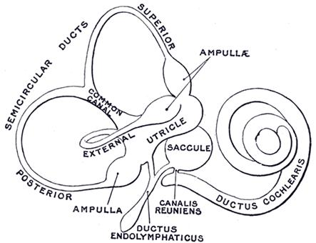
The membranous labyrinth.

VIDEO 1

VIDEO 2

The Semicircular Ducts (ductus semicirculares; membranous semicircular canals), (925, 926).—The semicircular ducts are about one-fourth of the diameter of the osseous canals, but in number, shape, and general form they are precisely similar, and each presents at one end an ampulla. They open by five orifices into the utricle, one opening being common to the medial end of the superior and the upper end of the posterior duct. In the ampullæ the wall is thickened, and projects into the cavity as a fiddle-shaped, transversely placed elevation, the septum transversum, in which the nerves end.
The utricle, saccule, and semicircular ducts are held in position by numerous fibrous bands which stretch across the space between them and the bony walls.

Structure
—The walls of the utricle, saccule, and semicircular ducts consist of three layers. The outer layer is a loose and flocculent structure, apparently composed of ordinary fibrous tissue containing bloodvessels and some pigment-cells. The middle layer, thicker and more transparent, forms a homogeneous membrana propria, and presents on its internal surface, especially in the semicircular ducts, numerous papilliform projections, which, on the addition of acetic acid, exhibit an appearance of longitudinal fibrillation. The inner layer is formed of polygonal nucleated epithelial cells. In the maculæ of the utricle and saccule, and in the transverse septa of the ampullæ of the semicircular ducts, the middle coat is thickened and the epithelium is columnar, and consists of supporting cells and hair cells. The former are fusiform, and their deep ends are attached to the membrana propria, while their free extremities are united to form a thin cuticle. The hair cells are flask-shaped, and their deep, rounded ends do not reach the membrana propria, but lie between the supporting cells. The deep part of each contains a large nucleus, while its more superficial part is granular and pigmented. The free end is surmounted by a long, tapering, hair-like filament, which projects into the cavity. The filaments of the acoustic nerve enter these parts, and having pierced the outer and middle layers, they lose their medullary sheaths, and their axis-cylinders ramify between the hair cells.
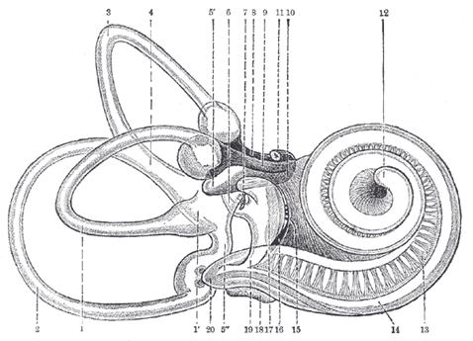
Right human membranous labyrinth, removed from its bony enclosure and viewed from the antero-lateral aspect.
Two small rounded bodies termed otoconia, each consisting of a mass of minute crystalline grains of carbonate of lime, held together in a mesh of gelatinous tissue, are suspended in the endolymph in contact wish the free ends of the hairs projecting from the maculæ. According to Bowman, a calcareoutmaterial is also sparingly scattered in the cells lining the ampullæ of the semicircular ducts.
F:\понеділок\gray\henry gray anatomy\www.bartleby.com\107\232.html - i925
VIDEO
http://intranet.tdmu.edu.ua/data/teacher/video/fiz_pat/Video1/F199077_innerear.mpg
The Ductus Cochlearis (membranous cochlea; scala media).—The ductus cochlearis consists of a spirally arranged tube enclosed in the bony canal of the cochlea and lying along its outer wall.
As already stated, the osseous spiral lamina extends only part of the distance between the modiolus and the outer wall of the cochlea, while the basilar membrane stretches from its free edge to the outer wall of the cochlea, and completes the roof of the scala tympani. A second and more delicate membrane, the vestibular membrane (Reissneri) extends from the thickened periosteum covering the osseous spiral lamina to the outer wall of the cochlea, where it is attached at some little distance above the outer edge of the basilar membrane. A canal is thus shut off between the scala tympani below and the scala vestibuli above; this is the ductus cochlearis or scala media (928). It is triangular on transverse section, its roof being formed by the vestibular membrane, its outer wall by the periosteum lining the bony canal, and its floor by the membrana basilaris and the outer part of the lamina spiralis ossea. Its extremities are closed; the upper is termed the lagena and is attached to the cupula at the upper part of the helicotrema; the lower is lodged in the recessus cochlearis of the vestibule. Near the lower end the ductus cochlearis is brought into continuity with the saccule by a narrow, short canal, the canalis reuniens of Hensen (924). On the membrana basilaris is situated the spiral organ of Corti. The vestibular membrane is thin and homogeneous, and is covered on its upper and under surfaces by a layer of epithelium. The periosteum, forming the outer wall of the ductus cochlearis, is greatly thickened and altered in character, and is called the spiral ligament. It projects inward below as a triangular prominence, the basilar crest, which gives attachment to the outer edge of the basilar membrane; immediately above the crest is a concavity, the sulcus spiralis externus. The upper portion of the spiral ligament contains numerous capillary loops and small bloodvessels, and is termed the stria vascularis.
The osseous spiral lamina consists of two plates of bone, and between these are the canals for the transmission of the filaments of the acoustic nerve. On the upper plate of that part of the lamina which is outside the vestibular membrane, the periosteum is thickened to form the limbus laminæ spiralis (929), this ends externally in a concavity, the sulcus spiralis internus, which represents, on section, the form of the letter C; the upper part, formed by the overhanging extremity of the limbus, is named the vestibular lip; the lower part, prolonged and tapering, is called the tympanic lip, and is perforated by numerous foramina for the passage of the cochlear nerves. The upper surface of the vestibular lip is intersected at right angles by a number of furrows, between which are numerous elevations; these present the appearance of teeth along the free surface and margin of the lip, and have been named by Huschke the auditory teeth (930). The limbus is covered by a layer of what appears to be squamous epithelium, but the deeper parts of the cells with their contained nuclei occupy the intervals between the elevations and between the auditory teeth. This layer of epithelium is continuous on the one hand with that lining the sulcus spiralis internus, and on the other with that covering the under surface of the vestibular membrane.
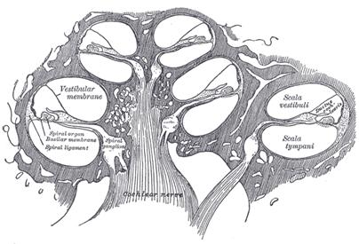
Diagrammatic longitudinal section of the cochlea.
Basilar Membrane.—The basilar membrane stretches from the tympanic lip of the osseous spiral lamina to the basilar crest and consists of two parts, an inner and an outer. The inner is thin, and is named the zona arcuata: it supports the spiral organ of Corti. The outer is thicker and striated, and is termed the zona pectinata. The under surface of the membrane is covered by a layer of vascular connective tissue; one of the vessels in this tissue is somewhat larger than the rest, and is named the vas spirale; it lies below Corti’s tunnel.
The spiral organ of Corti (organon spirale [Corti]; organ of Corti) (931, 932) is composed of a series of epithelial structures placed upon the inner part of the basilar membrane. The more central of these structures are two rows of rod-like bodies, the inner and outer rods or pillars of Corti. The bases of the rods are supported on the basilar membrane, those of the inner row at some distance from those of the outer; the two rows incline toward each other and, coming into contact above, enclose between them and the basilar membrane a triangular tunnel, the tunnel of Corti. On the inner side of the inner rods is a single row of hair cells, and on the outer side of the outer rods three or four rows of similar cells, together with certain supporting cells termed the cells of Deiters and Hensen. The free ends of the outer hair cells occupy a series of apertures in a net-like membrane, the reticular membrane, and the entire organ is covered by the tectorial membrane.
RODS OF CORTI.—Each of these consists of a base or foot-plate, and elongated part or body, and an upper end or head; the body of each rod is finely striated, but in the head there is an oval non-striated portion which stains deeply with carmine. Occupying the angles between the rods and the basilar membrane are nucleated cells which partly envelop the rods and extend on to the floor of Corti’s tunnel; these may be looked upon as the undifferentiated parts of the cells from which the rods have been formed.
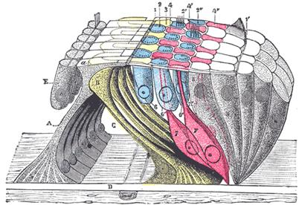
The lamina reticularis and subjacent structures. (Schematic.) A. Internal rod of Corti, with a, its plate. B. External rod (in yellow). C. Tunnel of Corti. D. Membrana basilaris. E. Inner hair cells. 1, 1’. Internal and external borders of the membrana reticularis. 2, 2’, 2”. The three rows of circular holes (in blue). 3. First row of phalanges (in yellow). 4, 4’, 4”. Second, third, and fourth rows of phalanges (in red). 6, 6’, 6”. The three rows of outer hair cells (in blue). 7, 7’, 7”. Cells of Deiters. 8. Cells of Hensen and Claudius.
F:\понеділок\gray\henry gray anatomy\www.bartleby.com\107\232.html - i932
The inner rods number nearly 6000, and their bases rest on the basilar membrane close to the tympanic lip of the sulcus spiralis internus. The shaft or body of each is sinously curved and forms an angle of about 60 degrees with the basilar membrane. The head resembles the proximal end of the ulna and presents a deep concavity which accommodates a convexity on the head of the outer rod. The head-plate, or portion overhanging the concavity, overlaps the head-plate of the outer rod.
The outer rods, nearly 4000 in number, are longer and more obliquely set than the inner, forming with the basilar membrane an angle of about 40 degrees. Their heads are convex internally; they fit into the concavities on the heads of the inner rods and are continued outward as thin flattened plates, termed phalangeal processes, which unite with the phalangeal processes of Deiters’ cells to form the reticular membrane.

Hair Cells.—The hair cells are short columnar cells; their free ends are on a level with the heads of Corti’s rods, and each is surmounted by about twenty hair-like processes arranged in the form of a crescent with its concavity directed inward. The deep ends of the cells reach about half-way along Corti’s rods, and each contains a large nucleus; in contact with the deep ends of the hair cells are the terminal filaments of the cochlear division of the acoustic nerve. The inner hair cells are arranged in a single row on the medial side of the inner rods, and their diameters being greater than those of the rods it follows that each hair cell is supported by more than one rod. The free ends of the inner hair cells are encircled by a cuticular membrane which is fixed to the heads of the inner rods. Adjoining the inner hair cells are one or two rows of columnar supporting cells, which, in turn, are continuous with the cubical cells lining the sulcus spiralis internus. The outer hair cells number about 12,000, and are nearly twice as long as the inner. In the basal coil of the cochlea they are arranged in three regular rows; in the apical coil, in four, somewhat irregular, rows.
Between the rows of the outer hair cells are rows of supporting cells, called the cells of Deiters; their expanded bases are planted on the basilar membrane, while the opposite end of each presents a clubbed extremity or phalangeal process. Immediately to the outer side of Deiters’ cells are five or six rows of columnar cells, the supporting cells of Hensen. Their bases are narrow, while their upper parts are expanded and form a rounded elevation on the floor of the ductus cochlearis. The columnar cells lying outside Hensen’s cells are termed the cells of Claudius. A space exists between the outer rods of Corti and the adjacent hair cells; this is called the space of Nuel.
The reticular lamina (932) is a delicate frame-work perforated by rounded holes which are occupied by the free ends of the outer hair cells. It extends from the heads of the outer rods of Corti to the external row of the outer hair cells, and is formed by several rows of “minute fiddle-shaped cuticular structures,” called phalanges, between which are circular apertures containing the free ends of the hair cells. The inner most row of phalanges consists of the phalangeal processes of the outer rods of Corti; the outer rows are formed by the modified free ends of Deiters’ cells.
Covering the sulcus spiralis internus and the spiral organ of Corti is the tectorial membrane, which is attached to the limbus laminæ spiralis close to the inner edge of the vestibular membrane. Its inner part is thin and overlies the auditory teeth of Huschke; its outer part is thick, and along its lower surface, opposite the inner hair cells, is a clear band, named Hensen’s stripe, due to the intercrossing of its fibers. The lateral margin of the membrane is much thinner. Hardesty 151 considers the tectorial membrane as the vibrating mechanism in the cochlea. It is inconceivably delicate and flexible; far more sensitively flexible in the transverse than in the longitudinal direction and the readiness with which it bends when touched is beyond description. It is ectodermal in origin. It consists of fine colorless fibers embedded in a transparent matrix (the matrix may be a variety of soft keratin), of a soft collagenous, semisolid character with marked adhesiveness. The general transverse direction of the fibers inclines from the radius of the cochlea toward the apex.
The acoustic nerve (n. acusticus; auditory nerve or nerve of hearing) divides near the bottom of the internal acoustic meatus into an anterior or cochlear and a posterior or vestibular branch.
The vestibular nerve (n. vestibularis) supplies the utricle, the saccule, and the ampullæ of the semicircular ducts. On the trunk of the nerve, within the internal acoustic meatus, is a ganglion, the vestibular ganglion (ganglion of Scarpa); the fibers of the nerve arise from the cells of this ganglion. On the distal side of the ganglion the nerve splits into a superior, an inferior, and a posterior branch. The filaments of the superior branch are transmitted through the foramina in the area vestibularis superior, and end in the macula of the utricle and in the ampullæ of the superior and lateral semicircular ducts; those of the inferior branch traverse the foramina in the area vestibularis inferior, and end in the macula of the saccule. The posterior branch runs through the foramen singulare at the postero-inferior part of the bottom of the meatus and divides into filaments for the supply of the ampulla of the posterior semicircular duct.
The cochlear nerve (n. cochlearis) divides into numerous filaments at the base of the modiolus; those for the basal and middle coils pass through the foramina in the tractus spiralis foraminosis, those for the apical coil through the canalis centralis, and the nerves bend outward to pass between the lamellæ of the osseous spiral lamina. Occupying the spiral canal of the modiolus is the spiral ganglion of the cochlea (ganglion of Corti), consisting of bipolar nerve cells, which constitute the cells of origin of this nerve. Reaching the outer edge of the osseous spiral lamina, the fibers of the nerve pass through the foramina in the tympanic lip; some end by arborizing around the bases of the inner hair cells, while others pass between Corti’s rods and across the tunnel, to end in a similar manner in relation to the outer hair cells. The cochlear nerve gives off a vestibular branch to supply the vestibular end of the ductus cochlearis; the filaments of this branch pass through the foramina in the fossa cochlearis (page 1048).
Vessels.—The arteries of the labyrinth are the internal auditory, from the basilar, and the stylomastoid, from the posterior auricular. The internal auditory artery divides at the bottom of the internal acoustic meatus into two branches: cochlear and vestibular. The cochlear branch subdivides into twelve or fourteen twigs, which traverse the canals in the modiolus, and are distributed, in the form of a capillary net-work, in the lamina spiralis and basilar membrane. The vestibular branches are distributed to the utricle, saccule, and semicircular ducts.
The veins of the vestibule and semicircular canals accompany the arteries, and, receiving those of the cochlea at the base of the modiolus, unite to form the internal auditory veins which end in the posterior part of the superior petrosal sinus or in the transverse sinus.

Auditory tract
1. Body of first neuron of auditory tract positioned in cochlear ganglion (spiral cochlear ganglion). The peripheral process of first neurons terminates in spiral organ and the central process neurons form cochlear part of VІІІ cranial nerve. It passes through the internal auditory meatus into cranial cavity, where terminates by synapse with second neuron.
2. The bodies of second neurons of cochlear nerve are found in anterior and posterior cochlear nucleus in lateral recess of rhomboid fossa. Axons of second neurons form fascicles having a name trapezoid body. These fibres terminate partly in superior olivar nucleus. One from posterior cochlear nucleus form striae medullaris of fourth ventricle.
3. The third neuron of auditory tract positioned in superior olivar nucleus. Their axons a lateral lemniscus, which runs through the isthmus of rhombencephalon (triangle of lemniscus) and reach the subcortical hearing centres.

The bodies of fourth neurons of auditory tract located in medial geniculate body and inferior colliculus of midbrain. Then axons run through the posterior third of posterior leg of internal capsule and reach Geshla gyrus (cortical hearing analyser in superior temporal gyrus). Axons of the fourth neurons also pass from inferior colliculus to the anterior funiculus of spinal cord as vestibulospinal tract. Instantaneous reaction in response to sound (protective reflex) realises by means of this pathway.

